CLOUD COMPUTING LAB

Name: Maria Abdul Malik
Reg No: 2023-BSE-076
Submitted to: Sir Muhammad Shoaib
Class: 5B
LAB #04
- Task 1: Verify VM resources in VMware
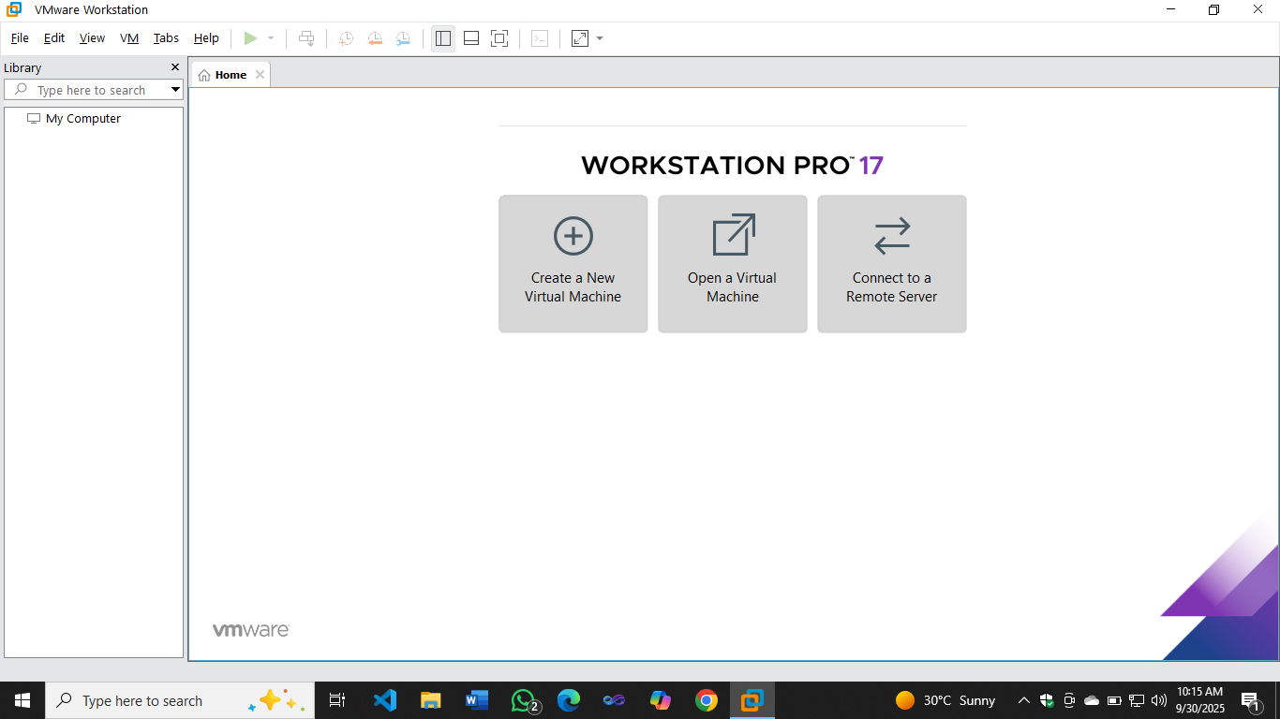
vm_settings.png

Task 2 – Start VM and log in
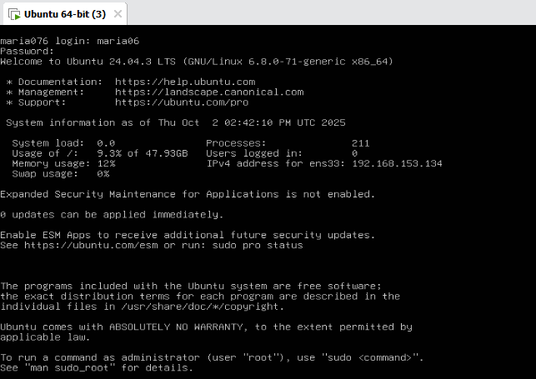
Vm.login.png
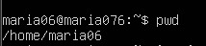
Whoami_pwd.png
Task 3 – Filesystem exploration — root tree and dotfiles
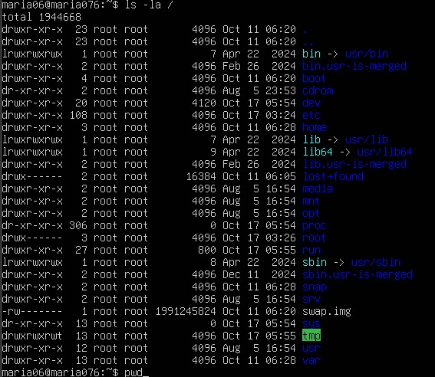
Ls_root.png
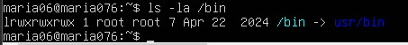
Ls_bin.png
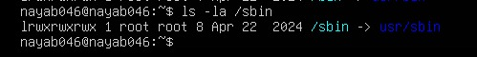
Ls_sbin.png
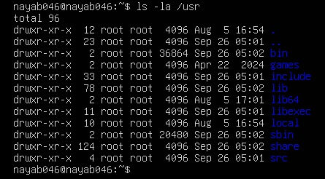
Ls-usr.png
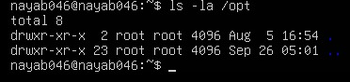
Ls_opt.png
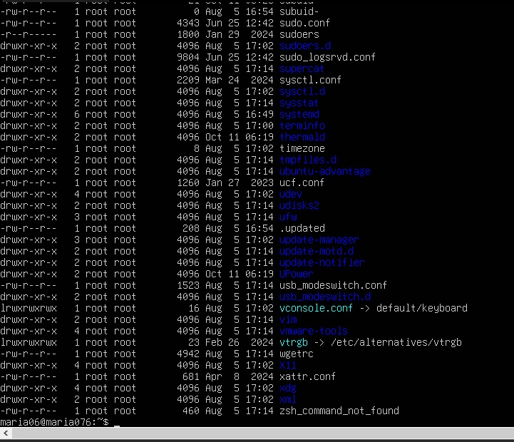
Ls_etc.png
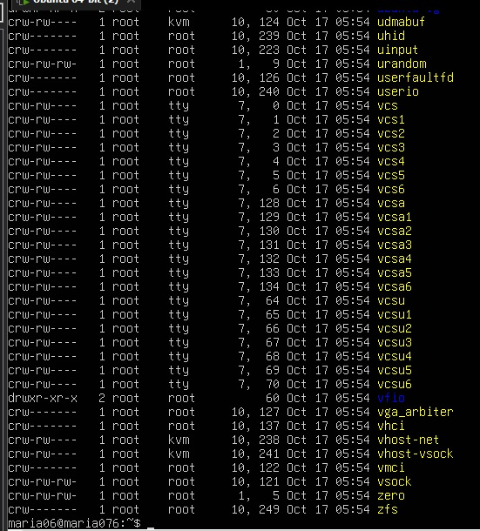
Ls_dev.png
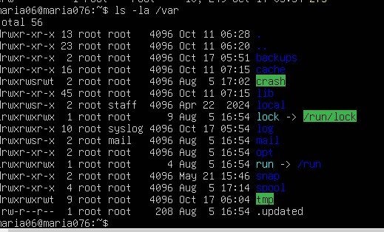
Ls_var.png
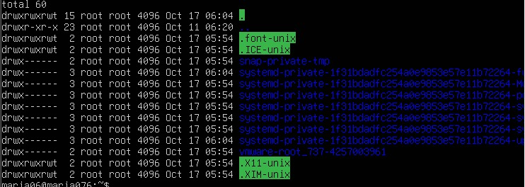
Ls_temp.png
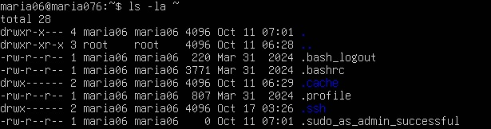
home_ls.png
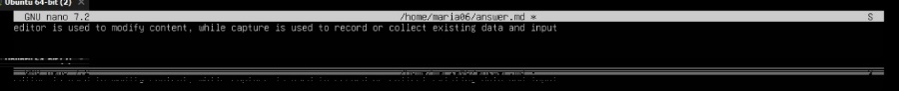
answers_md.png
Task 4 – Essential CLI tasks — navigation and file operations
mkdir_workspace.png
cd_workspace.png
pwd_workspace.png
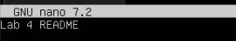
nano_readme.png
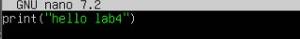
nano_main.png
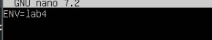
nano_env.png
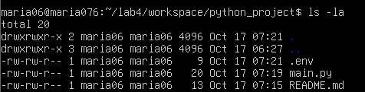
workspace_ls.png
cp_readme.png
mv_readme.png
rm_readme.png
mkdir_java_app.png
cp_recursive.png
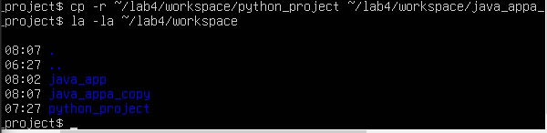
copy_verify.png
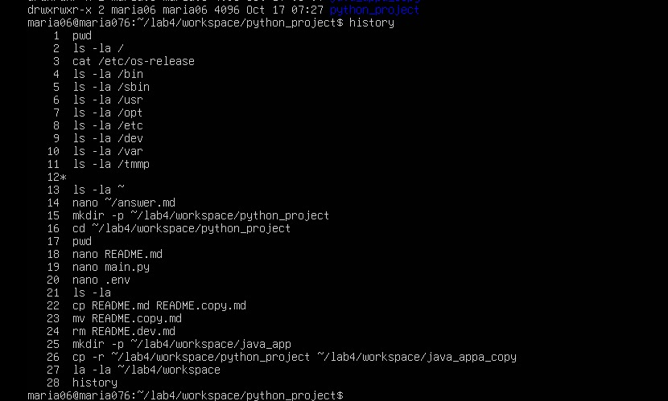
history.png
Task 5 – System info, resources & processes
uname.png
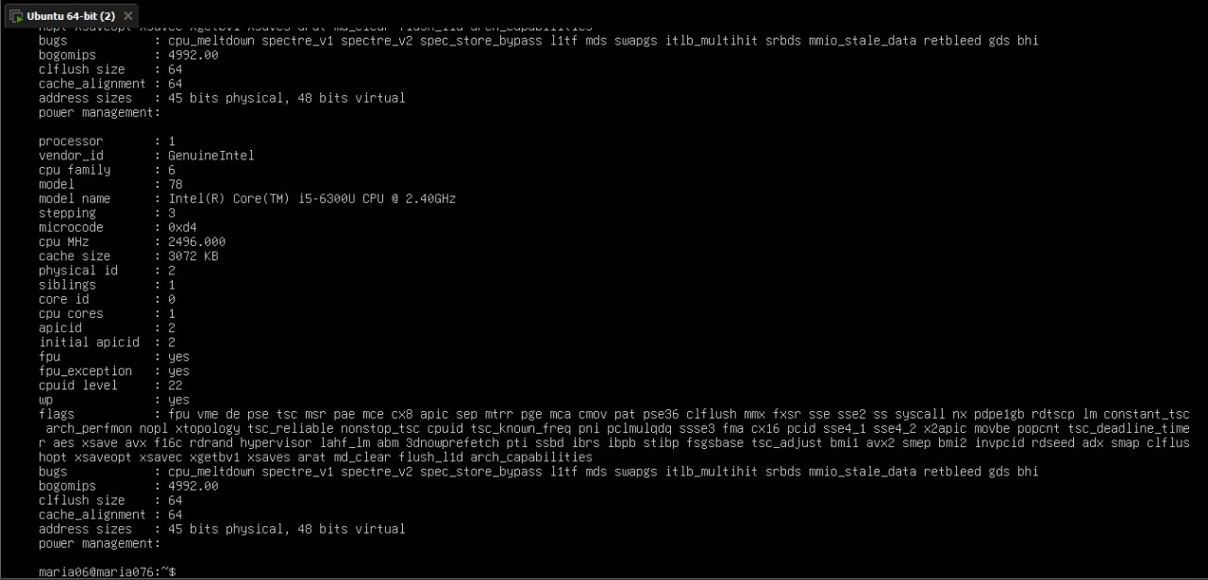
cpuinfo.png
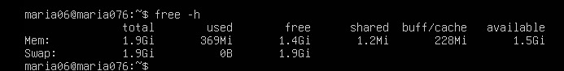
meminfo.png
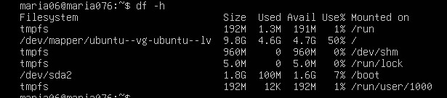
diskinfo.png
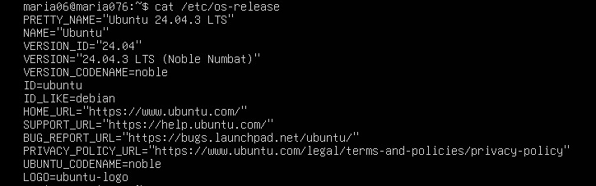
os-release.png
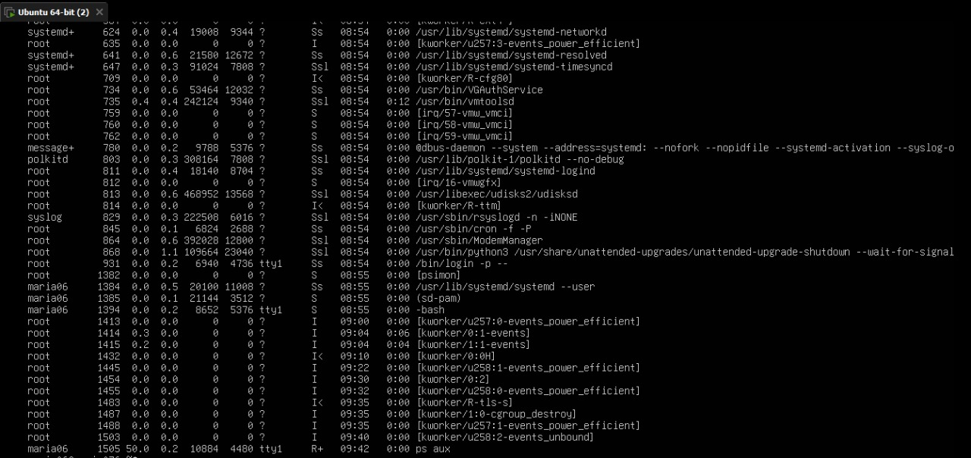
processes.png
Task 6 – Users and account verification (no sudo group change)
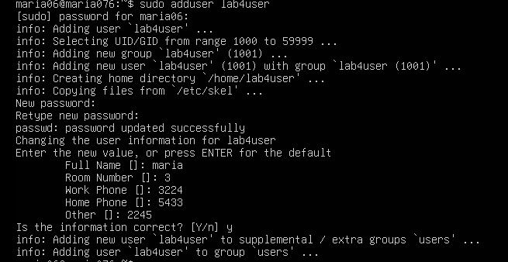
adduser_lab4user.png
lab4user_passwd.png
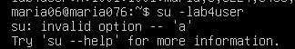
su_lab4user.png
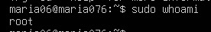
sudo_whoami.png
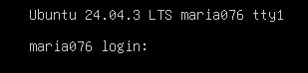
exit_back.png
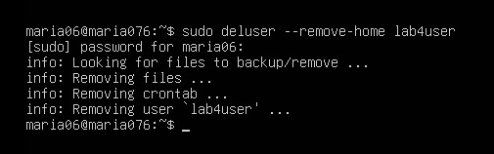
deluser.png

